Last Updated: May 2022

WriteAway Promotional Strategies
WriteAway promotion can focus on two main audiences: students and instructors. Reaching students and instructors can be done both in-person or online. Below you’ll find a week by week schedule of promotional activities you can consider. Feel free to pick and choose strategies that work for your institution!

WriteAway Suggested Promotion Schedule

Weeks Prior to WriteAway Opening
- Encourage instructors to add a WriteAway in their course syllabi and embed a button or link on their course websites
Tools: WriteAway logo and web button http://writeaway.ca/coordinators/promotion
- Attend departmental/faculty meetings to inform instructors about WriteAway and provide information about how they can encourage their students to use WriteAway
Tools: Faculty Information Sheet http://writeaway.ca/content/faculty-information
- Print materials for orientation packages and start of semester events
Tools: Posters, handbills, bookmarks http://writeaway.ca/coordinators/promotion
- Identify classes that would benefit from WriteAway – review course syllabi with writing components
- Note learning outcomes in writing courses and collaborate with Admin Centre to focus promotion for First-Year courses

Weeks 1-3
- Meet with instructors to clarify benefits of WriteAway and arrange in-class visits to promote service to students
Tools: Faculty Information Sheet http://writeaway.ca/content/faculty-information
- Email targeted course instructors of potential classes
Tools: Script for inviting course instructors - Below
- Remind writing and learning centre staff about recommending WriteAway to students and provide print materials to handout
Tools: Posters, handbills, bookmarks http://writeaway.ca/coordinators/promotion
- Share information about WriteAway service opening in email newsletters to students, instructors, and staff
Tools: Script for email newsletter (1) - Below
- Advertise opening of WriteAway service on library/learning centre webpage and social media (see examples below)

Weeks 4-6
- Conduct in-class visits to inform students about WriteAway service

- Share print material with students in class and with instructors through departmental mailboxes

- Use posters and handbills in writing and learning centres to advertise WriteAway
Tools: Posters, handbills, bookmarks http://writeaway.ca/coordinators/promotion

Weeks 7-10
- Create social media posts to remind students about submitting to WriteAway in advance of midterm assignments and other course deadlines

- Share information about WriteAway service opening in (departmental, library, institutional) email newsletters to students, instructors, and staff
Tools: Script for email newsletter (2) - Below
- Create social media posts to remind students about submitting to WriteAway in advance of course deadlines

Promotional Tools and Scripts
WriteAway can be promoted in conjunction with your in-house and online writing services.
- Logo, web-button, & print materials: http://writeaway.ca/coordinators/promotion
- Faculty Information Sheet: http://writeaway.ca/content/faculty-information
- Scripts for email (can be modified to suit your individual institutional needs)
Scripts for Inviting Course Instructors to Promote WriteAway
**Ensure that the script is updated with current service dates and institutional names**
Attachment: Faculty Information Sheet: http://writeaway.ca/content/faculty-information
Dear <INSTRUCTOR>,
<INSTITUTION> participates in WriteAway, a service that supports undergraduate students by providing personalized formative feedback on their writing. Qualified tutors at post-secondary institutions across the province offer suggestions and resources to help students revise their writing and develop their writing skills..
Students may submit their work to WriteAway online, any time between <SERVICE DATES>, and they can usually expect feedback within 24-48 hours. Accessing WriteAway is easy. Students visit writeaway.ca/connect, select <INSTITUTION> and submit their work.
I am attaching a document that outlines more information about what WriteAway is and how it can help <INSTITUTION> students.
Please feel free to contact me at <CONTACT INFO> to speak further about how WriteAway and <INSTITUTION> services are available for your students.
<CLOSING>
Script for institutional email newsletter (1)
WriteAway is now open!
Students can submit their writing for fast, friendly, and free feedback from highly trained online tutors. Tutors provide strategies and resources to help students improve their writing and each assignment can receive feedback up to three times. Students can submit work online, any time, and can generally expect to receive feedback within 24-48 hours.
Students can submit their writing now at writeaway.ca/connect
Script for institutional email newsletter (2)
Are you ready to write your term papers? WriteAway can help!
<INSTITUTION NAME> students can receive free online writing help. Submit up to three drafts of your paper and tutors will share strategies and resources to help you improve your writing
Submit your assignment now at writeaway.ca/connect

Online Promotion: Best Practices
Here are some suggested best practices to use when promoting WriteAway online:
- Include a permanent link to WriteAway on high-traffic landing pages (e.g. Writing Centre homepage, Library homepage).
2. Include a short description with the link (see example below).
3. Use either the WriteAway button or the Logo to link to WriteAway.
Bringing it all together – here is an example of how online promotion might look on a webpage:
WriteAway Writing Support

WriteAway is a free, fast, and friendly online writing support service. Submit your assignment and tutors will provide strategies and resources to help you improve your writing. Tutors do their best to share feedback within 48 hours. Submit your writing by clicking the button below:
<button should link to writeaway.ca/connect>

For more information about WriteAway, please visit WriteAway Frequently Asked Questions. <link here to https://writeaway.ca/faq-page>

Online Promotion Examples (2019)
Social Media (UBC Okanagan)

Twitter Post
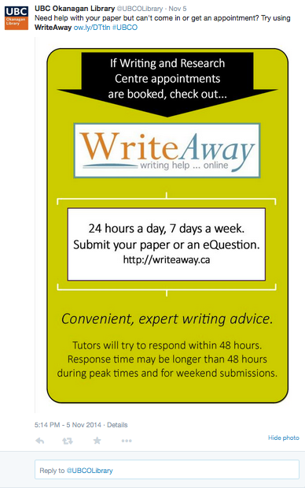
Hyperlinks in in social media posts that connect to writing services login pages

Facebook Post
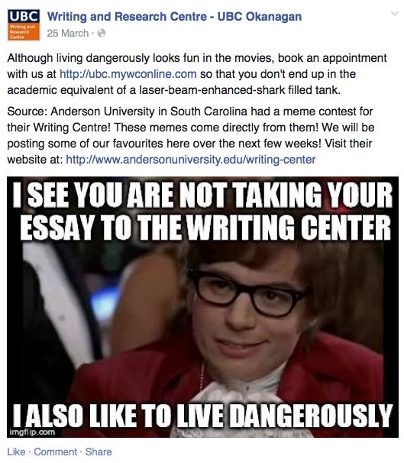

LMS (College of the Rockies)

Institutional Moodle Homepage
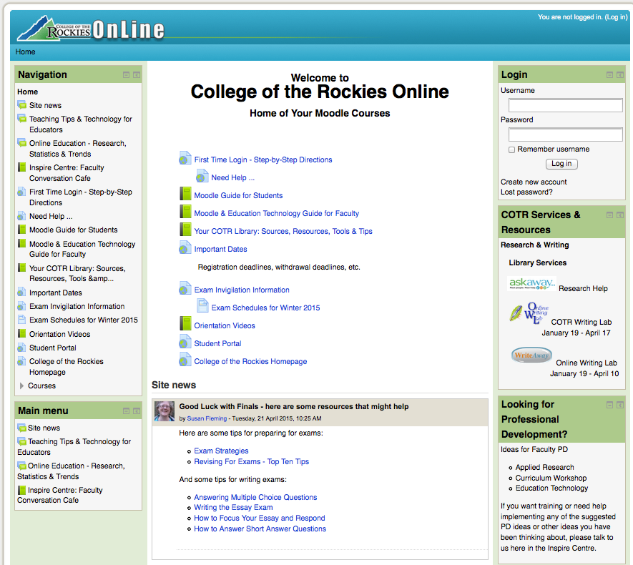
WriteAway button accessible from student’s LMS login

